Technical design

  - Monthly expenses
The purpose of this program is to calculate a person's monthly expenses. It will show the total expenses, the highest expense, and the lowest expense.
Input
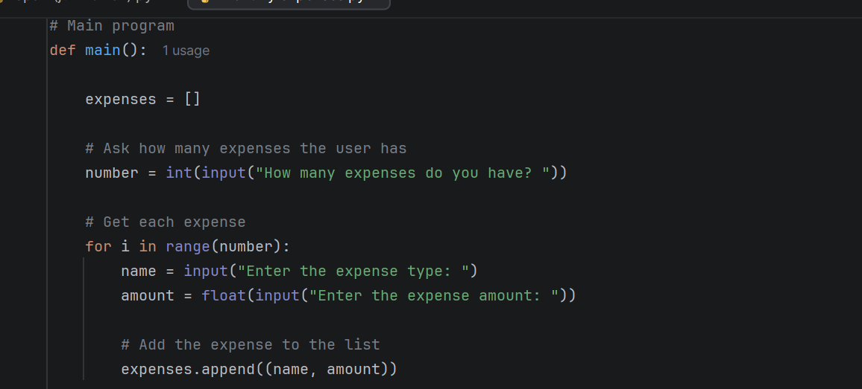

The program asks the user how many expenses they have. Then, the user enters the type of each expense and its amount.

Examples include rent, food, gas, and bills.

Processing

The program stores the expenses in a list. It uses the `reduce()` method to calculate the total expenses and find the highest and lowest expenses.

The program uses separate functions to perform each calculation.
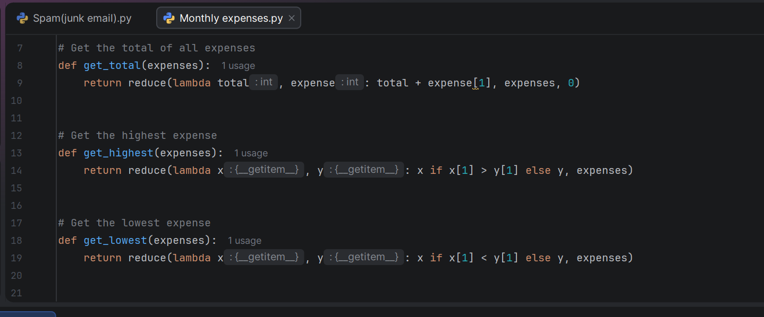

Output

The program displays the total amount of all expenses, the highest expense with its name and amount, and the lowest expense with its name and amount.

Program Steps

1. Start the program.
2. Ask the user how many expenses they have.
3. Ask for the type and amount of each expense.
4. Store the expenses in a list.
5. Calculate the total expenses using `reduce()`.
6. Find the highest and lowest expenses using `reduce()`.
7. Display the results.
8. End the program.
Testing

I tested the program using three expenses.

Example input:

Rent: $900
Food: $250
Gas: $80

Expected output:
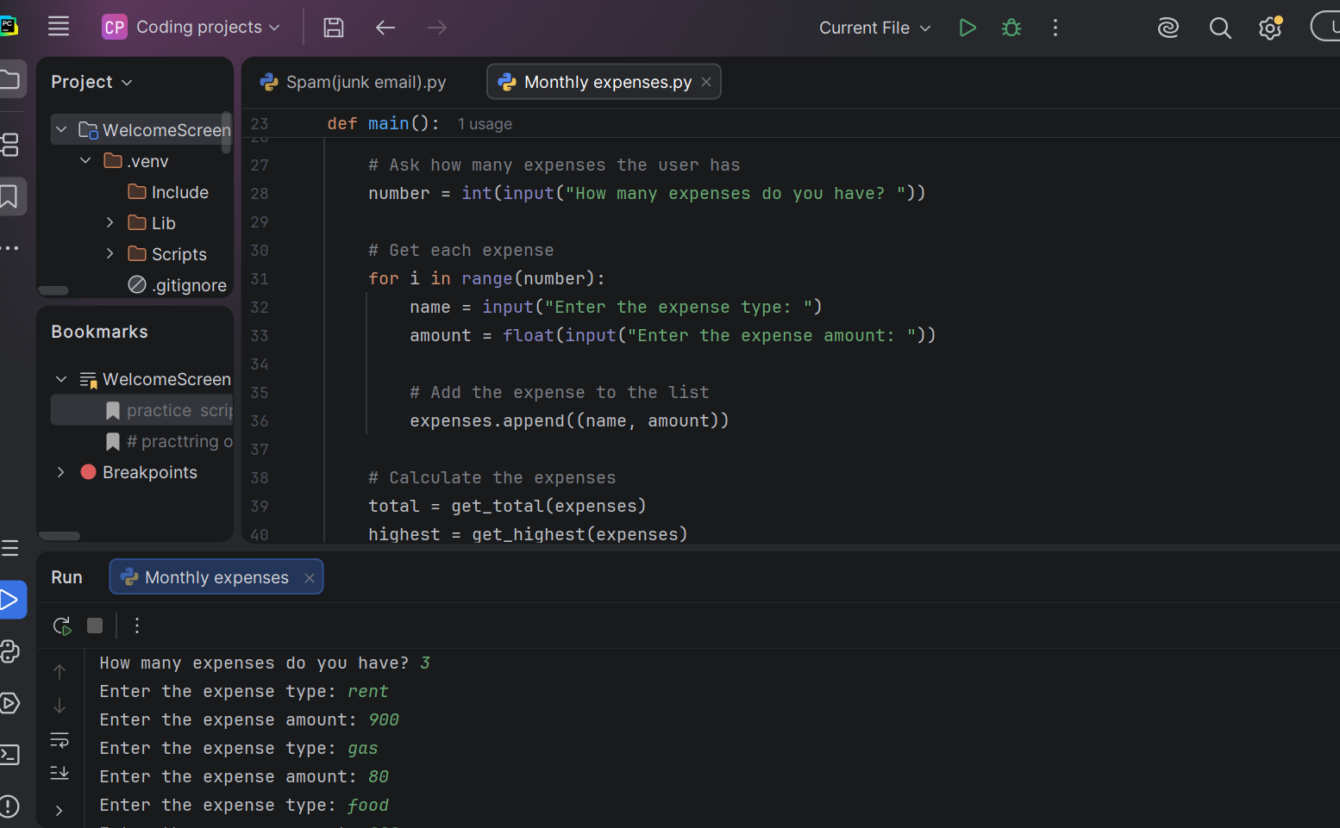

Total expense: $1260.00
Highest expense: Rent - $900.00
Lowest expense: Gas - $80.00
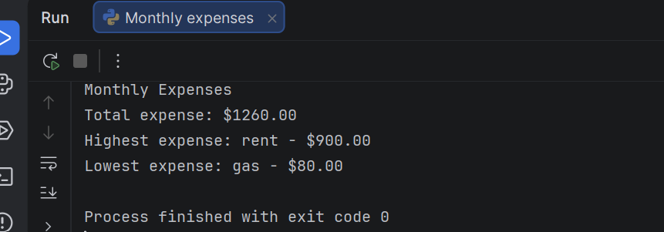

Conclusion
This program helps users understand how much they spend each month. It uses lists, loops, functions, and the `reduce()` method to calculate and display the results.

